Joined-Figure Composition

Definition
# Source: AI Source: Provided by: [Data Path: Persons Table -> ID Column: 1, Name_En Column: Motasem Essam] -> From: [ChatGPT] on [7/25/2026]
Joined-Figure Composition is a type of geometric figure composition in which two or more geometric figures are joined along a point, a segment, an edge, or another boundary portion to form a larger geometric configuration.
The resulting figure may have a new overall outline, while the original components remain identifiable.

Simple Definition
# Source: AI Source: Provided by: [Data Path: Persons Table -> ID Column: 1, Name_En Column: Motasem Essam] -> From: [ChatGPT] on [7/25/2026]
Joined-figure composition means joining two or more geometric shapes together to create a larger figure.
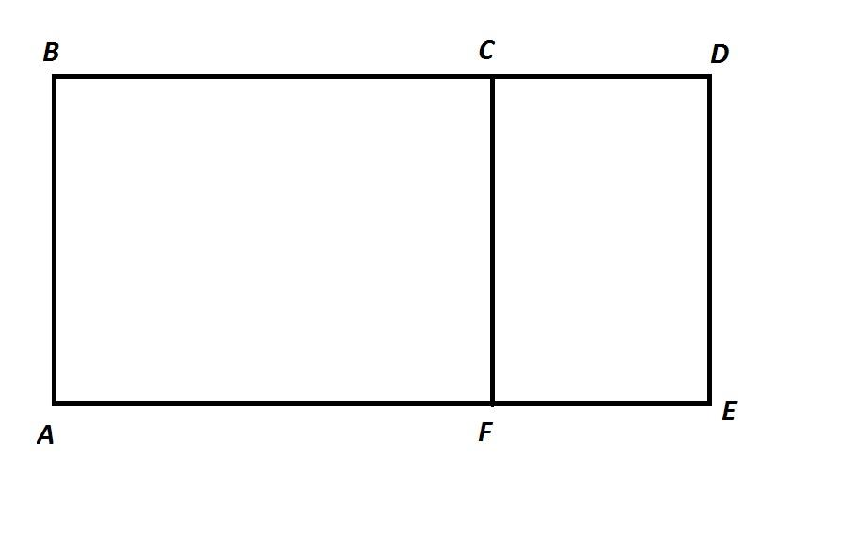
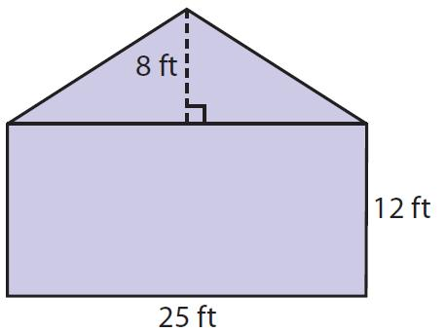
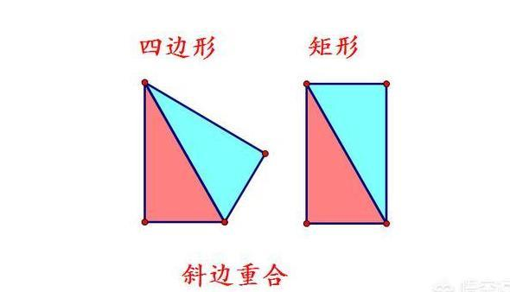

Main Classification
# Source: AI Source: Provided by: [Data Path: Persons Table -> ID Column: 1, Name_En Column: Motasem Essam] -> From: [ChatGPT] on [7/25/2026]
The following is a practical classification of joined-figure composition based on how the component figures are connected. These labels are descriptive, not a universally standardized mathematical taxonomy.

1. Full-Side Joined-Figure Composition
# Source: AI Source: Provided by: [Data Path: Persons Table -> ID Column: 1, Name_En Column: Motasem Essam] -> From: [ChatGPT] on [7/25/2026]
Two figures are joined along an entire side or edge of each figure.
Example: Two rectangles sharing a complete side to form one larger rectangle.
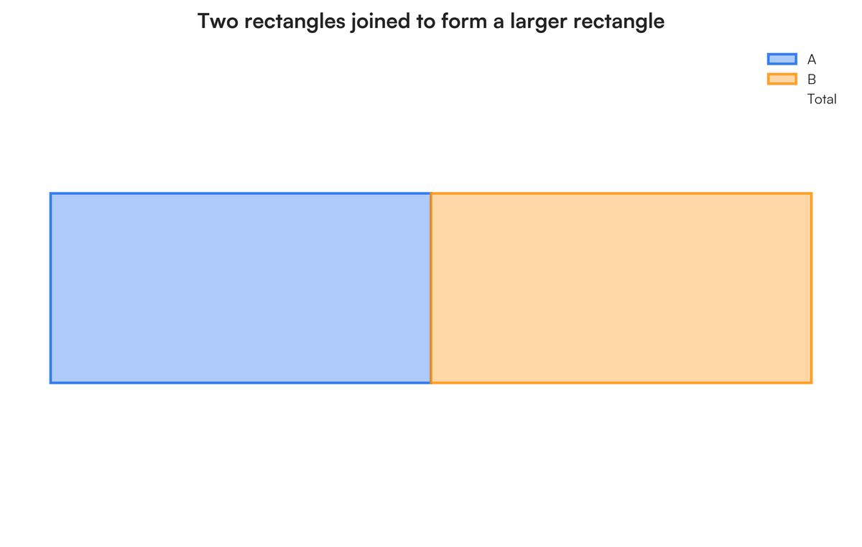
Detailed Explanation and Examples
Definition: Two figures are joined along the entirety of a corresponding side or edge.
Example: Two rectangles measuring $5×3$and $4×3$units share a complete side of length $3$.
The resulting figure is a $9×3$rectangle.
$$A_{\text{total}}=5\left(3\right)+4\left(3\right)$$
$$\boxed{A_{\text{total}}=27}$$
The shared boundary is internal to the composite figure, so it is not included in the outer perimeter.

2. Partial-Side Joined-Figure Composition
# Source: AI Source: Provided by: [Data Path: Persons Table -> ID Column: 1, Name_En Column: Motasem Essam] -> From: [ChatGPT] on [7/25/2026]
Figures are connected along only part of a side or boundary.
Example: A small triangle attached to part of a rectangle's edge.
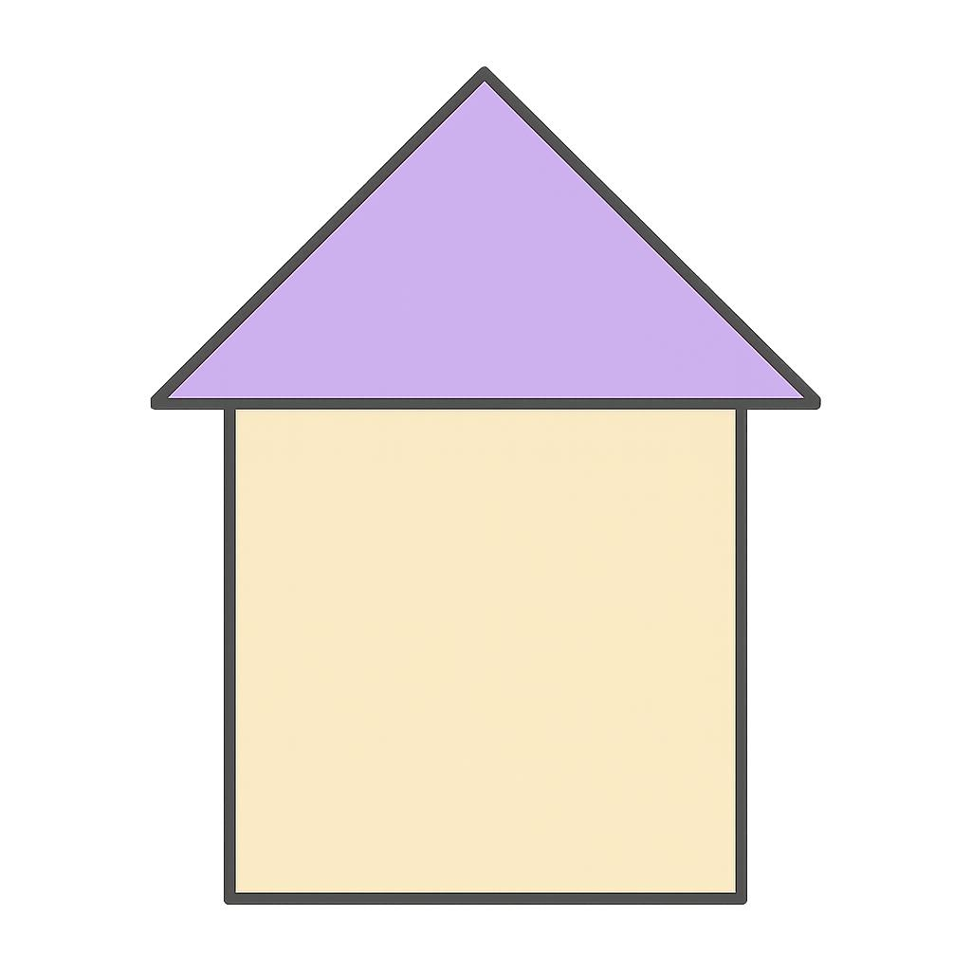
Detailed Explanation and Examples
Definition: Two figures are joined along only a portion of one or both of their boundaries.
Example: A triangle is attached to the middle portion of a rectangle's upper edge.
If the rectangle has area $A_{1}$and the triangle has area $A_{2}$, and their interiors do not overlap, then
$$A_{\text{total}}=A_{1}+A_{2}$$
The resulting outline depends on the triangle's dimensions and the length of the shared boundary.

3. Point-Joined Figure Composition
# Source: AI Source: Provided by: [Data Path: Persons Table -> ID Column: 1, Name_En Column: Motasem Essam] -> From: [ChatGPT] on [7/25/2026]
Two figures meet at a single point.
Example: Two triangles sharing one vertex but no side.
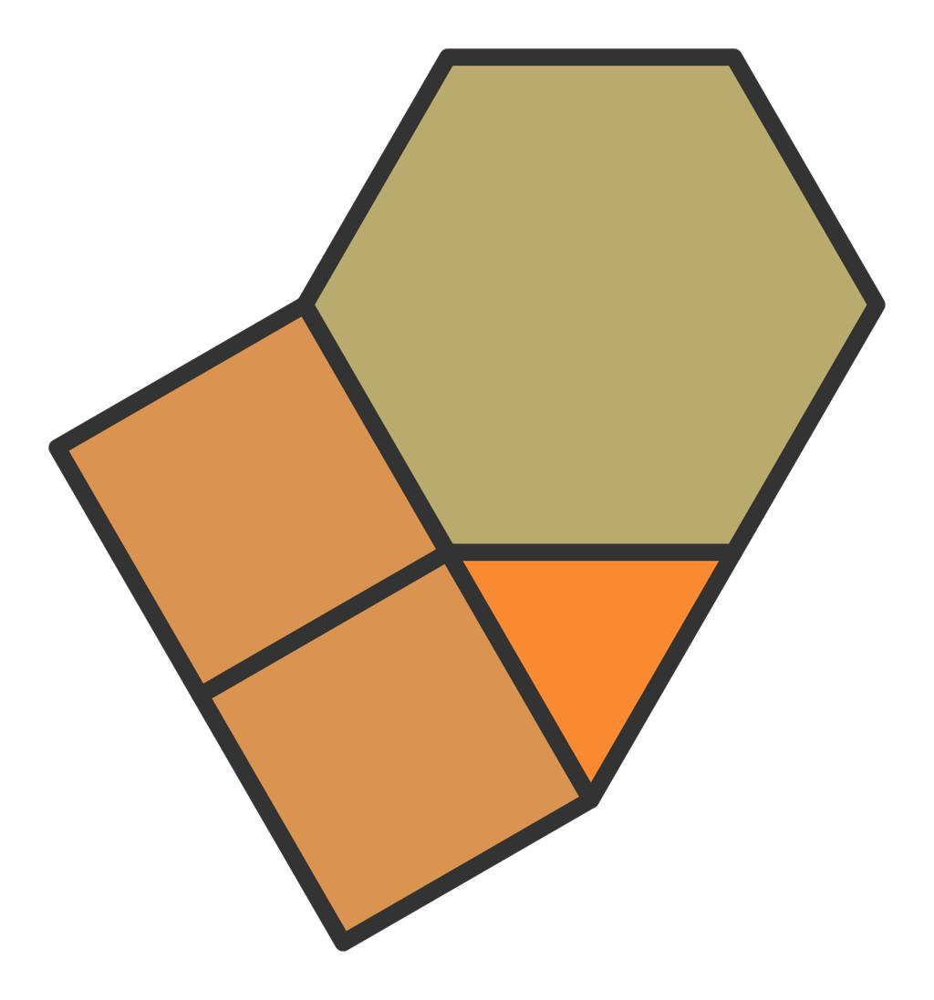
Detailed Explanation and Examples
Definition: Two figures meet at exactly one point, without sharing a boundary segment.
Example: Two triangles meet at a common vertex $O$.
The combined configuration contains both triangles, but the connection is only at $O$.
If their interiors are disjoint, their combined area is
$$A_{\text{total}}=A_{1}+A_{2}$$
Important: Sharing a point does not necessarily produce a single simple polygon. The exact result depends on the arrangement of the figures.

4. Edge-Joined Figure Composition
# Source: AI Source: Provided by: [Data Path: Persons Table -> ID Column: 1, Name_En Column: Motasem Essam] -> From: [ChatGPT] on [7/25/2026]
Two figures share a common edge or segment.
Example: Two triangles joined along a common side to form a quadrilateral.
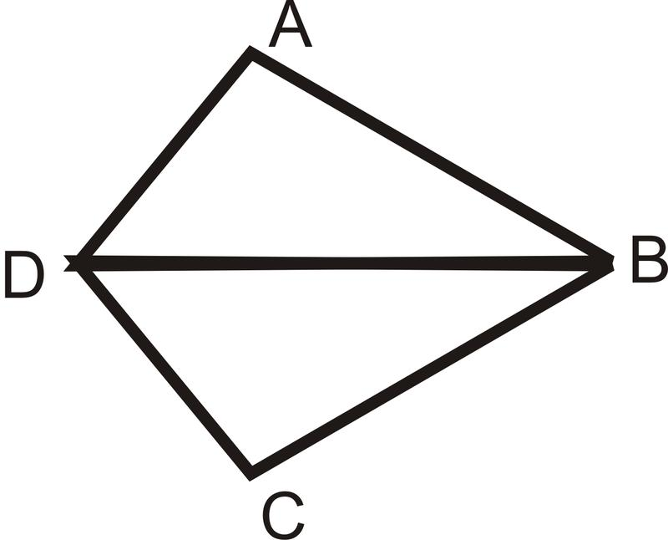
Detailed Explanation and Examples
Definition: Two figures share a common edge or line segment.
Example: Two triangles share side $AB$, with their third vertices on opposite sides of $AB$.
Together, they can form a quadrilateral.
If the triangles have bases $b$along $AB$and respective heights $h_{1}$and $h_{2}$, their combined area is
$$A_{\text{total}}=\frac{1}{2}bh_{1}+\frac{1}{2}bh_{2}$$
Therefore,
$$\boxed{A_{\text{total}}=\frac{1}{2}b\left(h_{1}+h_{2}\right)}$$
The shared side is internal and does not contribute to the outer perimeter.

5. Mixed-Shape Joined-Figure Composition
# Source: AI Source: Provided by: [Data Path: Persons Table -> ID Column: 1, Name_En Column: Motasem Essam] -> From: [ChatGPT] on [7/25/2026]
Different types of geometric figures are connected.
Example: A rectangle joined to a semicircle along its diameter.
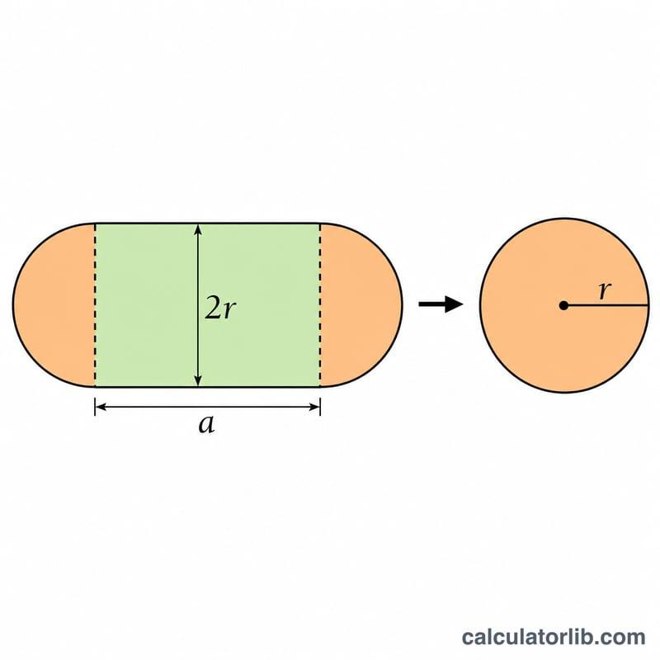
Detailed Explanation and Examples
Definition: Two or more different geometric shape types are connected to form a composite figure.
Example: A rectangle of length $L$and width $2r$is joined to a semicircle of radius $r$along a side equal to the semicircle's diameter.
The combined area is
$$A_{\text{total}}=2rL+\frac{1}{2}πr^{2}$$
For $L=6$and $r=2$,
$$A_{\text{total}}=24+2π$$
square units.

6. Multiple-Figure Joined Composition
# Source: AI Source: Provided by: [Data Path: Persons Table -> ID Column: 1, Name_En Column: Motasem Essam] -> From: [ChatGPT] on [7/25/2026]
Three or more figures are joined to create a single larger configuration.
Example: Three rectangles joined to form an L-shaped region.
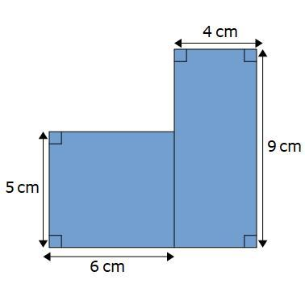
Detailed Explanation and Examples
Definition: Three or more geometric figures are joined to form a larger configuration.
Example: Three rectangles form an L-shaped region.
If the rectangles have non-overlapping interiors and areas $A_{1},A_{2},A_{3}$, then
$$\boxed{A_{\text{total}}=A_{1}+A_{2}+A_{3}}$$
For instance, if the areas are $12$, $8$, and $6$square units, the total area is $26$square units.

Important Mathematical Rules

Area
# Source: AI Source: Provided by: [Data Path: Persons Table -> ID Column: 1, Name_En Column: Motasem Essam] -> From: [ChatGPT] on [7/25/2026]
When the component interiors do not overlap,
$$A_{\text{total}}=\sum_{i=1}^{n}{A_{i}}$$
If components overlap in area, the overlap must be subtracted from the sum.
Perimeter
The perimeter of the composite figure is the length of its outer boundary only.
For two polygons sharing an edge of length $s$, with no other shared boundary portions,
$$\boxed{P_{\text{total}}=P_{1}+P_{2}-2s}$$
The shared edge is counted once in each original perimeter, so both occurrences must be removed.

Perimeter
# Source: AI Source: Provided by: [Data Path: Persons Table -> ID Column: 1, Name_En Column: Motasem Essam] -> From: [ChatGPT] on [7/25/2026]
The perimeter of the composite figure is the length of its outer boundary only.
For two polygons sharing an edge of length sss, with no other shared boundary portions,
Ptotal=P1+P2−2s\boxed{P_{\text{total}}=P_1+P_2-2s}Ptotal=P1+P2−2s
The shared edge is counted once in each original perimeter, so both occurrences must be removed.

Shape and Connectivity
# Source: AI Source: Provided by: [Data Path: Persons Table -> ID Column: 1, Name_En Column: Motasem Essam] -> From: [ChatGPT] on [7/25/2026]
- Joining along an edge often produces a connected composite region.
- Joining at a point produces a connected set, but may not produce a simple polygon.
- The outer boundary depends on the relative positions and orientations of the components.
- Joining figures does not necessarily make the result a regular or familiar geometric shape.

Joined-Figure Composition vs. Related Concepts
# Source: AI Source: Provided by: [Data Path: Persons Table -> ID Column: 1, Name_En Column: Motasem Essam] -> From: [ChatGPT] on [7/25/2026]
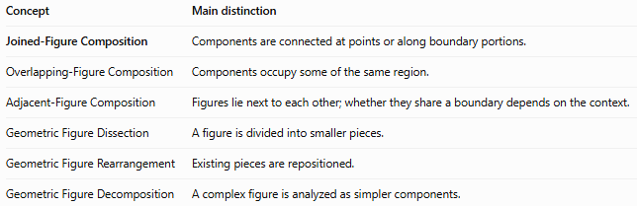
Concept | Main distinction
Joined-Figure Composition | Components are connected at points or along boundary portions.
Overlapping-Figure Composition | Components occupy some of the same region.
Adjacent-Figure Composition | Figures lie next to each other; whether they share a boundary depends on the context.
Geometric Figure Dissection | A figure is divided into smaller pieces.
Geometric Figure Rearrangement | Existing pieces are repositioned.
Geometric Figure Decomposition | A complex figure is analyzed as simpler components.

Classification Summary
# Source: AI Source: Provided by: [Data Path: Persons Table -> ID Column: 1, Name_En Column: Motasem Essam] -> From: [ChatGPT] on [7/25/2026]
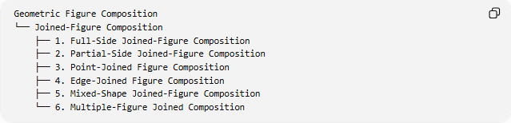
Geometric Figure Composition
└── Joined-Figure Composition
├── 1. Full-Side Joined-Figure Composition
├── 2. Partial-Side Joined-Figure Composition
├── 3. Point-Joined Figure Composition
├── 4. Edge-Joined Figure Composition
├── 5. Mixed-Shape Joined-Figure Composition
└── 6. Multiple-Figure Joined Composition
These categories can overlap. For example, a configuration made from three rectangles may be both a full-side joined composition and a multiple-figure joined composition.

Key Points
# Source: AI Source: Provided by: [Data Path: Persons Table -> ID Column: 1, Name_En Column: Motasem Essam] -> From: [ChatGPT] on [7/25/2026]
- Joined-figure composition connects two or more geometric figures.
- The connection may occur at a point, along part of a side, or along an entire edge.
- Component areas can be added directly when their interiors do not overlap.
- Shared internal boundaries must be excluded when calculating the outer perimeter.
- The classification above is a practical descriptive scheme rather than a universal formal taxonomy.

Conclusion
# Source: AI Source: Provided by: [Data Path: Persons Table -> ID Column: 1, Name_En Column: Motasem Essam] -> From: [ChatGPT] on [7/25/2026]
Joined-Figure Composition describes the formation of a larger geometric configuration by connecting smaller figures at points or along shared boundary portions. It is useful for studying composite shapes, calculating areas and perimeters, and understanding how geometric components form larger figures.

